Week 4
1. spring-rest-hands-on
Create a Spring Web Project using Maven

com.cognizant.spring_learn.controller.HelloController
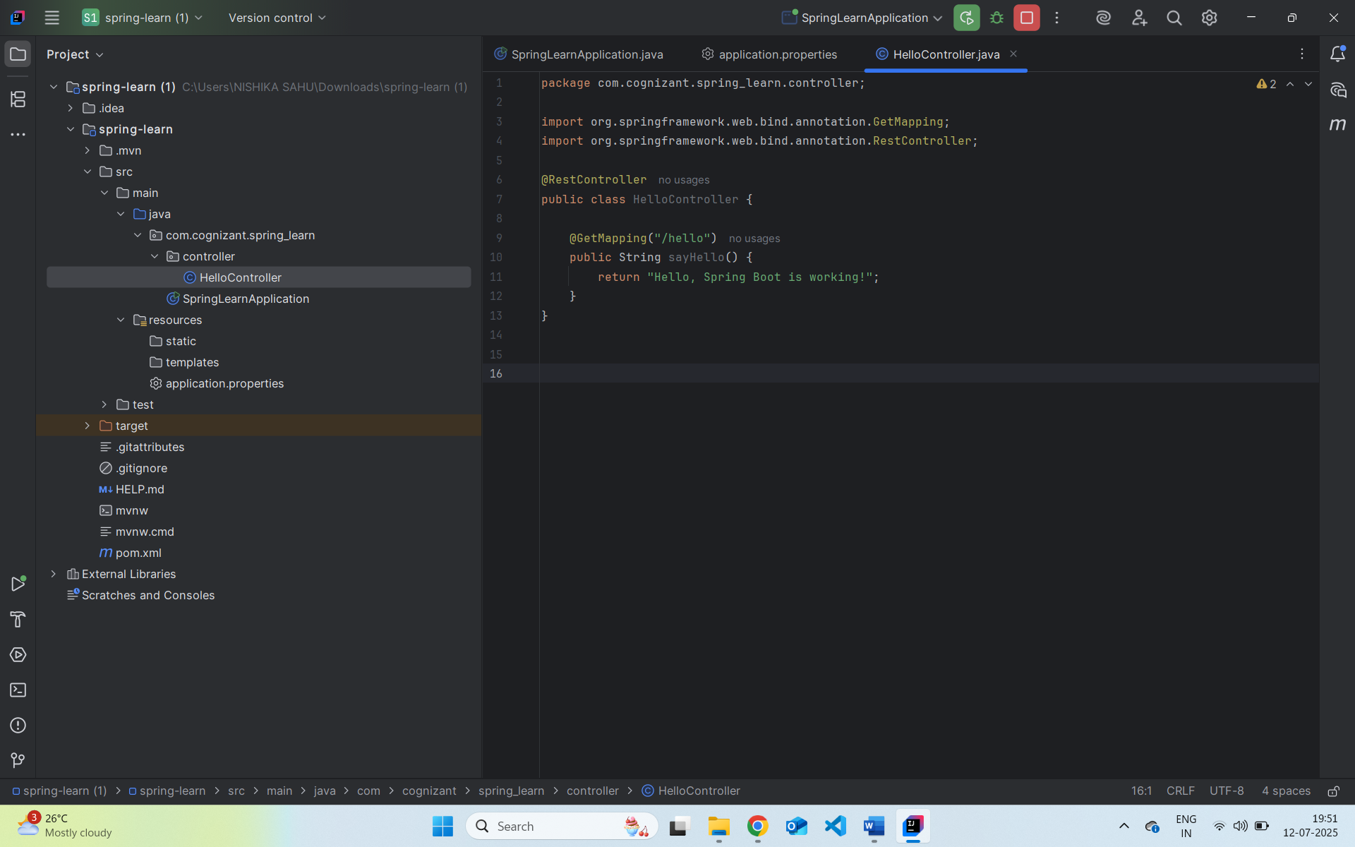

com.cognizant.spring_learn.SpringLearnApplication:
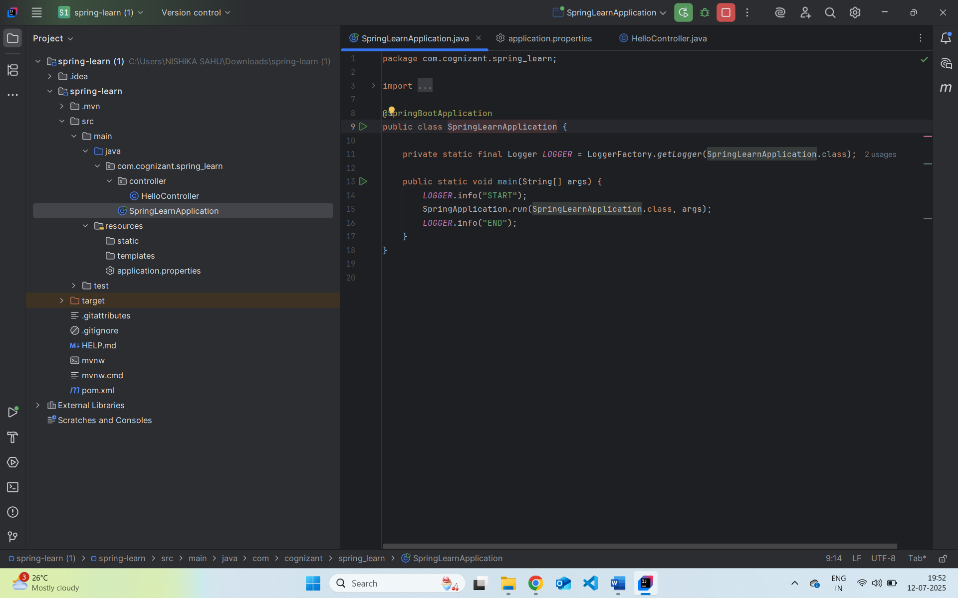

Output :
http://localhost:8083/hello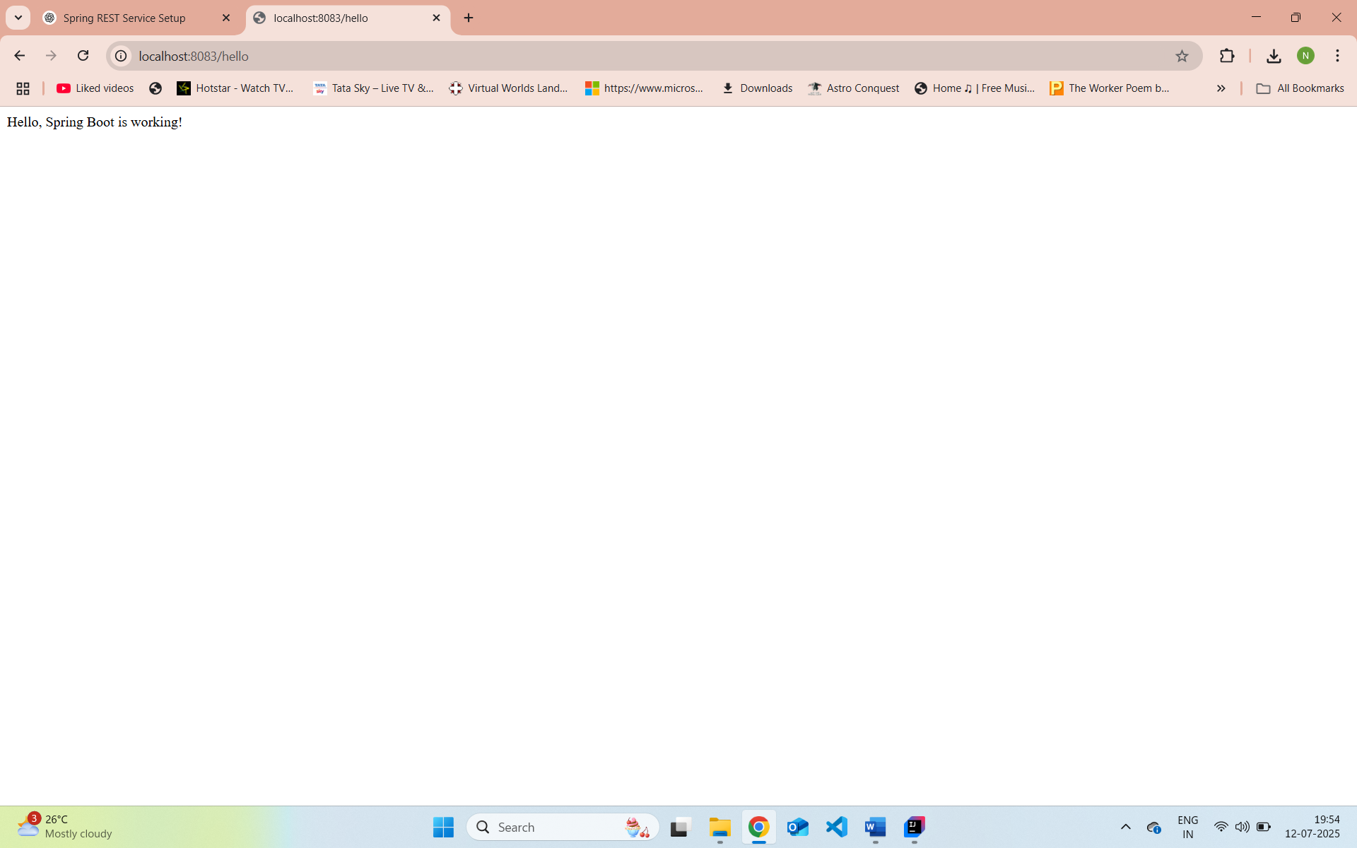
1. src/main/java – Application Code
This is the main source folder. Java packages and classes are written here.
2. src/main/resources – Configuration Files
Contains:
- application.properties or application.yml: app-level config
- Static content: in /static folder
- Templates (for Thymeleaf/Freemarker): in /templates
- Logback or XML files (if needed)
3. src/test/java – Test Code
Same package structure as main. You’ll use it to:
- Write unit tests using JUnit
- Write integration tests with Spring Test
4. SpringLearnApplication.java – Entry Point
java
@SpringBootApplication
public class SpringLearnApplication {
public static void main(String[] args) {
SpringApplication.run(SpringLearnApplication.class, args);
System.out.println("START");
}
}
- Starts the embedded Tomcat server
- Bootstraps Spring context
- Scans for beans (@Component, @Service, @RestController, etc.)
- 5. @SpringBootApplication – Key Annotation
- This annotation does 3 things:
- java
- CopyEdit
- @SpringBootApplication
- =
- @Configuration // Defines configuration class
- @EnableAutoConfiguration // Enables Spring Boot auto-config
- @ComponentScan // Enables component scanning in current package
6. pom.xml – Maven Build Configuration
Main responsibilities:
- Declares your project
- Sets parent (Spring Boot)
- Lists dependencies (Spring Web, DevTools, etc.)
- Configures Maven plugins
🔍 Example sections:
<parent>
<groupId>org.springframework.boot</groupId>
<artifactId>spring-boot-starter-parent</artifactId>
<version>3.2.4</version>
</parent>

<dependencies>
<dependency>
<groupId>org.springframework.boot</groupId>
<artifactId>spring-boot-starter-web</artifactId>
</dependency>

<dependency>
<groupId>org.springframework.boot</groupId>
<artifactId>spring-boot-devtools</artifactId>
<scope>runtime</scope>
</dependency>
</dependencies>

<build>
<plugins>
<plugin>
<groupId>org.springframework.boot</groupId>
<artifactId>spring-boot-maven-plugin</artifactId>
</plugin>
</plugins>
</build>
6.1 XML Configurations
If using XML (e.g. for loading country.xml), place the file in src/main/resources, and use:
java
InputStream input = new ClassPathResource("country.xml").getInputStream();
// Parse it with JAXB/StAX/etc.
6.2 View Dependency Hierarchy in Eclipse
Steps:
- Right-click project → Maven → Show Dependency Hierarchy
- You'll see:
  - Direct dependencies: spring-boot-starter-web, devtools
  - Transitive dependencies: spring-core, spring-context, jackson, tomcat, etc.
Useful for:
- Checking version conflicts
- Debugging build issues
- Verifying auto-config dependencies
Spring Core – Load Country from Spring Configuration XML
com.cognizant.spring_learn.Country.class
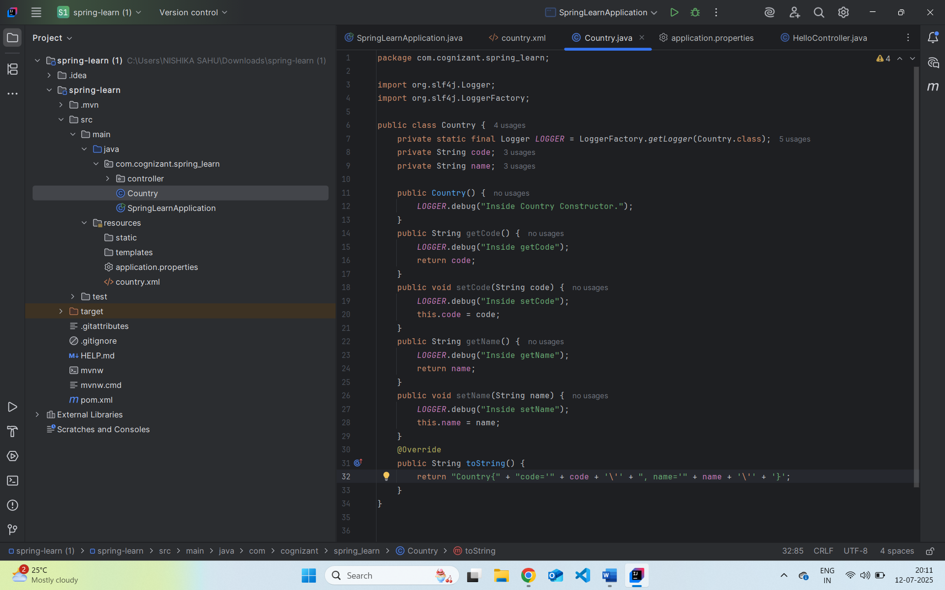

com.cognizant.spring_learn.SpringLearnApplication
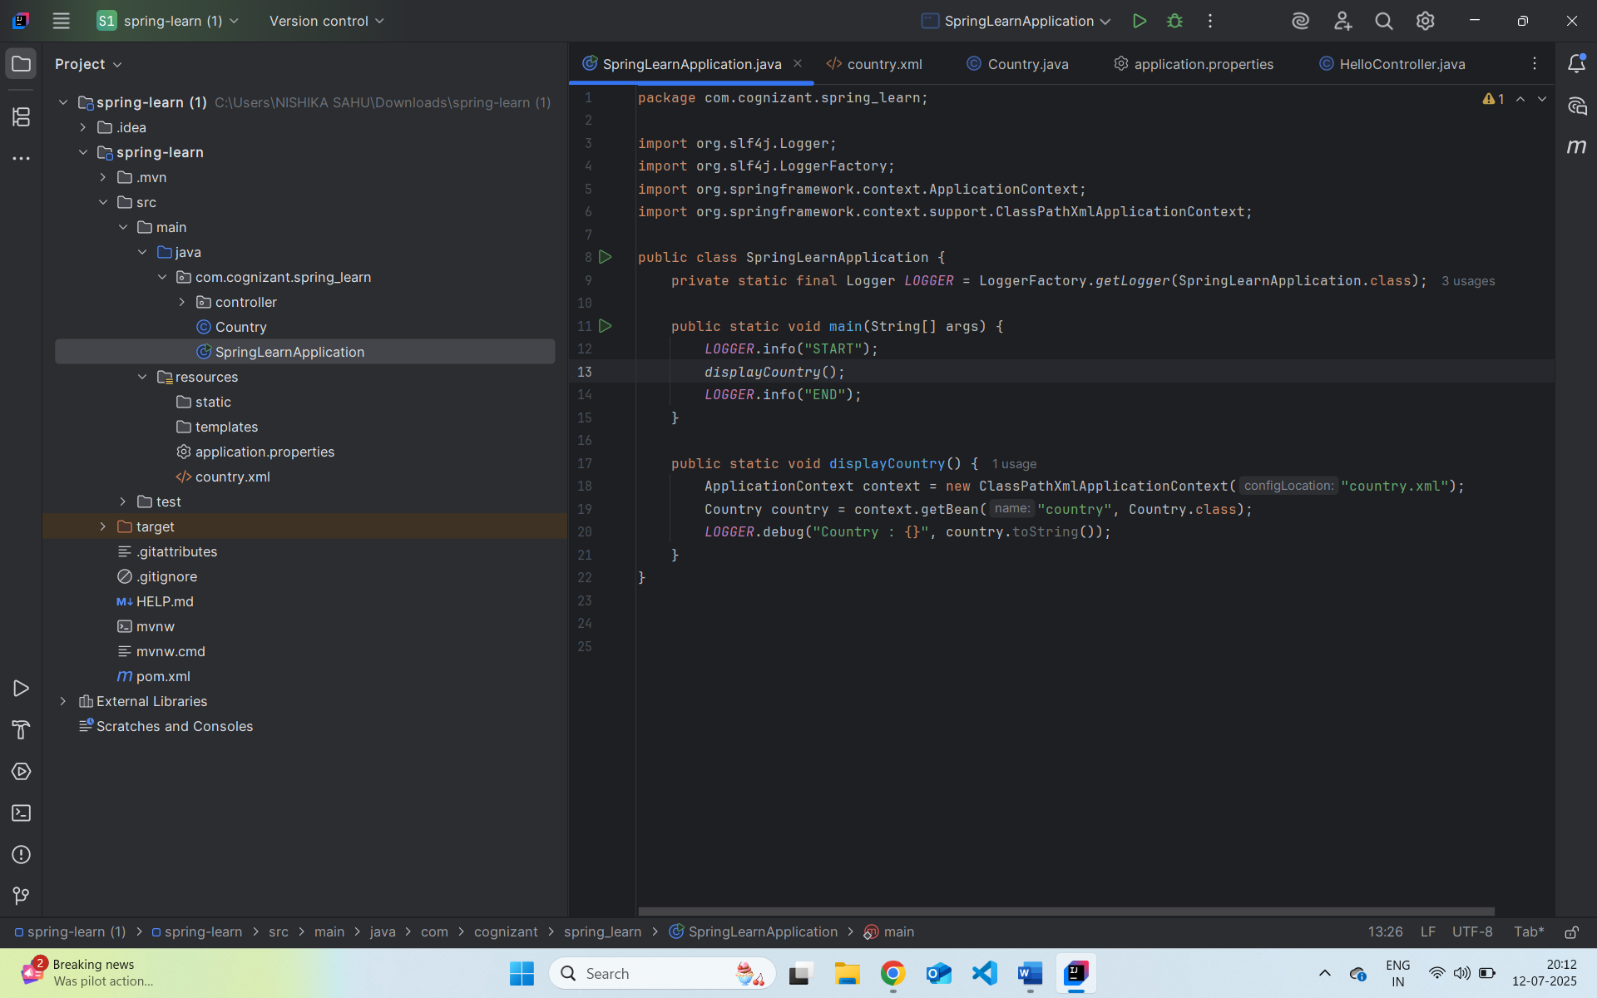
Country.xml
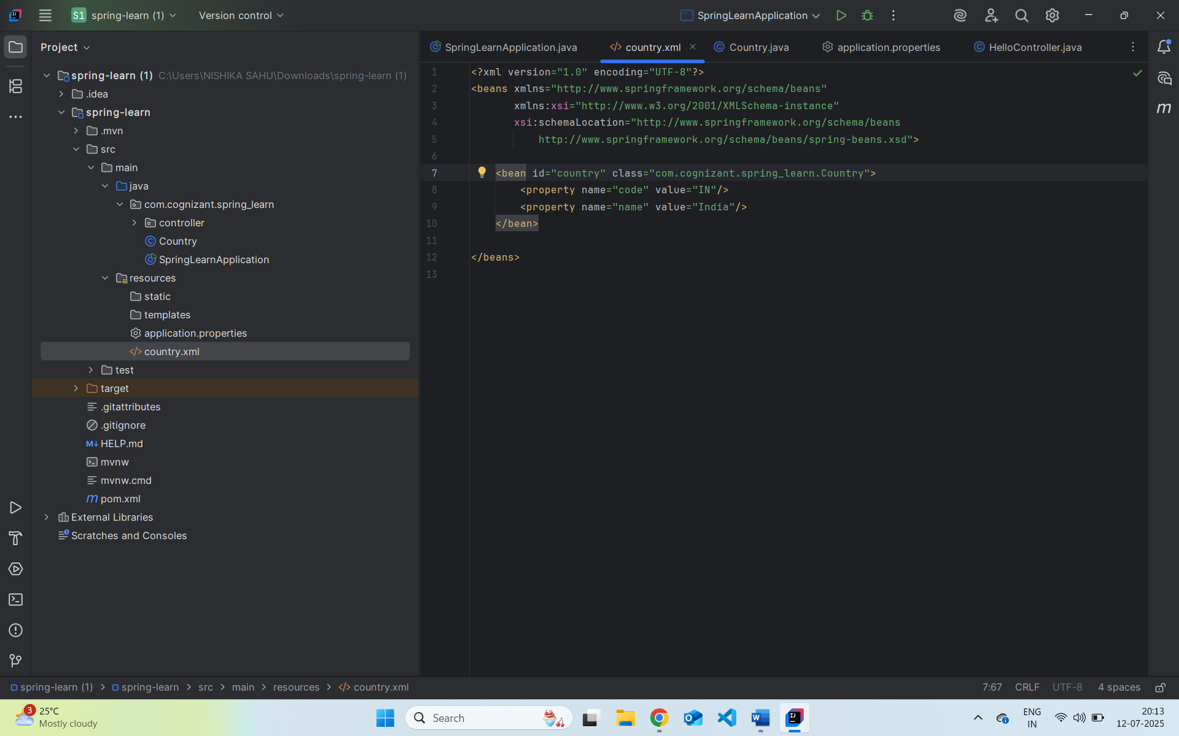
Output
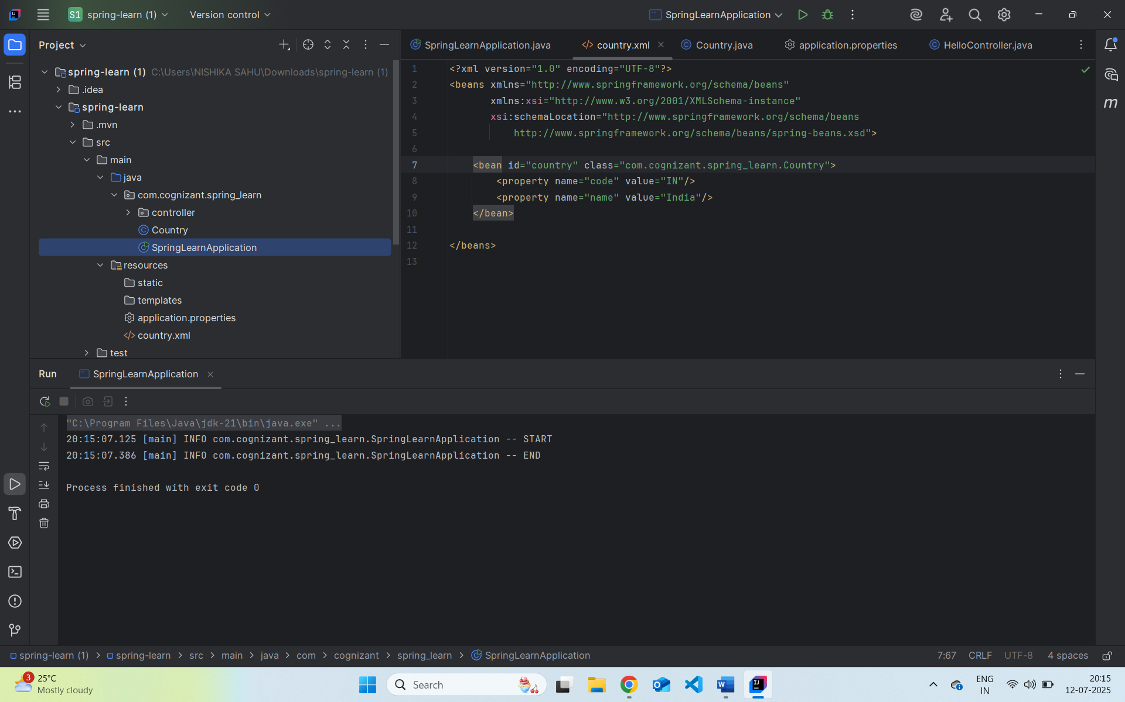
XML Configuration Tags:
- <bean>: Defines a Spring bean.
- id: Unique name for the bean.
- class: Fully qualified class name to instantiate.
- <property>: Sets a property of the bean via a setter method.
- name: Corresponds to the property (e.g., setName()).
- value: The value to inject.
ApplicationContext & ClassPathXmlApplicationContext
- ApplicationContext: Central interface for Spring’s IoC container.
- ClassPathXmlApplicationContext: Loads the context from an XML file located in classpath.
What happens during context.getBean():
- Spring container looks up the bean with the given ID.
- Instantiates the bean if it hasn't already.
- Injects dependencies (properties).
- Returns the bean reference to the caller.

